Bishop Moore College

Mavelikara



Project Report On

**STRUCTURAL AND OPTICAL ANALYSIS OF MoO3 NANOSTRUCTURE**

*Dissertation submitted to the University of Kerala*

*in partial fulfilment of the requirement for the award of the Degree of*

***Bachelor of Science in Physics***

By

**Riya Reny Reg No: 23020101010**

**Amruthambika Krishna Reg No: 23020101003**

**Anand Joy Reg No:23020101018**

**Under the guidance of**

**Dr. Arun Aravind**

**Assistant Professor, Department of Physics**

**Bishop Moore College Mavelikara**

CERTIFICATE

This is to certify that the dissertation entitled “ **STRUCTURAL AND OPTICAL ANALYSIS OF MoO3 NANOSTRUCTURE** “ by **Riya Reny** ( Reg No: 23020101010), **Amruthambika Krishna** ( Reg No: 23020101003 ) and **Anand Joy** ( Reg No: 23020101018 ) for the award of the degree of Bachelor of Science in Physics is an authentic work under my supervision and guidance during the period from 2020-2023.

Also certified, that the dissertation represents a teamwork from the part of the candidates

**Dr. Arun Aravind**

**Assistant Professor**

**Department of Physics**

**Bishop Moore College Mavelikara**

**Examiners:**

**1.**

**2.**

**DECLARATION OF ORIGINALITY**

We **Riya Reny (Reg No:23020101010)**, **Amruthambika Krishna (Reg No:230201010)** and **Anand Joy (Reg No:230201010)** hereby declare that the dissertation entitled “**STRUCTURAL AND OPTICAL ANALYSIS OF MoO3 NANOSTRUCTURE** “ represents our original work carried out as a Bachelor of Science student of University of Kerala and to the best of our knowledge contains no material previously published or written by another person, nor any material presented for the award of other degree or diploma of University of Kerala or any other institution. Any contribution made to this research by others, with whom we have worked at University of Kerala or elsewhere, is explicitly acknowledged in the dissertation. Work of other authors cited in this dissertation has been duly acknowledged under the section “Reference”. We are fully aware that in case of non-compliance detected in future, the Senate of University of Kerala may withdraw the degree awarded to me based on the present dissertation.

**Riya Reny**

**Amruthambika Krishna**

**Anand Joy**

**ACKNOWLEDGEMENT**

Foremost we would like to express our sincere gratitude to our guide **Dr. Arun Aravind Assistant Professor Bishop Moore College Mavelikara** for his continuous support, patience, motivation, enthusiasm and knowledge. He was always affectionate, hardworking and a source of inspiration to us all. His guidance helped at all times of research and drafting this project. We could not imagine having a better advisor and mentor for our research. The work could not have been possible without his suggestions and constant cooperation.

Besides our advisor, we're also thankful to **Dr. D Sajan, Head of the Department and Assistant Professor, Bishop Moore College, Mavelikara** for the help and guidance he provided to us for the initiation of this project. His dynamism, vision, sincerity and motivation have deeply inspired us. Our heart is filled with deep sense of thankfulness and obeisance to our teachers for their valuable suggestions. We also express our thanks to all faculty members of Bishop Moore College Mavelikara for their constant support.

A sincere thanks and gratitude to **Nithya S George** for her kind support during the project work. We are grateful for her inspiring and valuable suggestions during the entire period of our project work, which enabled us to complete the work successfully.

We are grateful to our parents for their love, prayer, care and sacrifices; we also thank our friends for giving us strength.

**Riya Reny**

**Amruthambika Krishna**

**Anand Joy**

**CONTENTS**

**1.Introduction**

**1.1 Nanoscience and Nanotechnology ............................................................................... 7**

**1.2 Nanoparticles and their Classification ........................................................................ 8**

**1.2.1 Classification of Nanomaterials ......................................................................... 8**

**1.2.2 Zero Dimensional Nanomaterials ...................................................................... 8**

**1.2.3 One Dimensional Nanomaterials ....................................................................... 9**

**1.2.4 Two Dimensional Nanomaterials ...................................................................... 9**

**1.2.5 Three Dimensional Nanomaterials ................................................................... 10**

**1.3 Properties of Nanomaterials ....................................................................................... 10**

**1.4 Synthesis approach for Nanoparticle Preparation ................................................... 11**

**1.4.1 Top-Down Approach .......................................................................................... 11**

**1.4.2 Bottom-Up Approach ......................................................................................... 11**

**1.5 Introduction to Transition Metal Oxide ......................................................................... 12**

**1.5.1 MoO3 Nanostructures ............................................................................................ 12**

**1.5.2 Crystal and Surface Structure of MoO3 ............................................................... 12**

**1.5.3 Applications of MoO3 Nanoparticles .................................................................... 13**

**2. Literature Review ............................................................................................................... 14**

**3. Characterization Techniques.............................................................................................. 16**

**3.1 Powder X-Ray Diffraction …................................................................................... 16**

**3.2 FESEM........................................................................................................................ 18**

**3.3 UV-Visible Spectroscopy........................................................................................... 19**

**4. Synthesis of Nanoparticles.................................................................................................. 22**

**4.1 Hydrothermal Method.............................................................................................. 22**

**4.2 Materials and Synthesis of MoO3 by Hydrothermal Method ….......................... 23**

**5. Result and Discussion ....................................................................................................... 24**

**6. Conclusion ......................................................................................................................... 27**

**References**

**Chapter-1**

**INTRODUCTION**

**1.1 Nanoscience and Nanotechnology**

The study of materials that have dimensions of the nanoscale level (1-100 nm where one nanometer is one thousand millionth of a meter) is called Nanoscience and clarifies the physical, chemical and biological phenomena of molecules at minute levels of precision. It involves hybridizing the mechanisms of physics and chemistry of complex systems.

  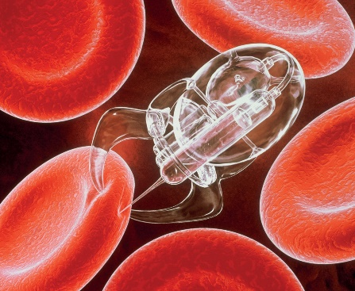

Fig 1.1 Neurolink Fig 1.2 Nanochips Fig 1.3 Nanodrug

Nanotechnology

The technology instrumental in analyzing and observing the properties of objects at nanoscale levels is called nanotechnology and is fundamental at noticing significant variations from its macroscopic or microscopic levels. Nanotechnology has the potential to revolutionize various industrial innovations including medicine, electronics, energy, and environmental science, by offering new solutions and opportunities for solving complex problems. It involves the use of advanced tools and techniques to create, design, and manipulate materials and devices with enhanced properties and functions.



Fig 1.4 Nanotechnology

**1.2 Nanoparticles and their classification**

Nanoparticles vary in size from a few nanometers to several thousand nanometers bridging the gap between bulk materials and Pico particles. Nanoparticles have a very high surface area to volume ratio reducing their melting temperature. Nanoparticles can be classified based on their dimensions, as the size of the particles plays an important role in determining their properties and behavior. Here are some common classifications of nanoparticles based on their dimensions

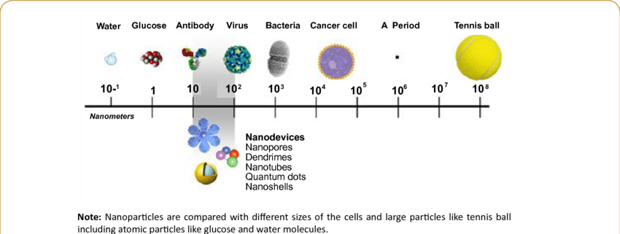

Figure 1.2.1 Size Range of Nanoparticles

**1.2.1 Zero-dimensional nanoparticles:**

These are nanoparticles that have all three dimensions x,y,z restricted to the nanoscale, such as quantum dots and fullerenes. These particles are typically spherical or nearly spherical in shape and have unique electronic and optical properties. They can come in amorphous or single crystalline structures that may or may not consist of multi chemical elements.



Figure 1.2.1 Zero Dimensional Nanoparticles

**1.2.2 One-dimensional nanomaterials:**

These are nanoparticles that have two dimensions on the nanoscale and one dimension greater than the nanometer range, such as nanowires, nanotubes, and nanorods. These particles have a high aspect ratio and can be used as building blocks for various applications.

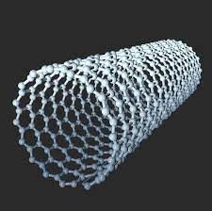

Figure 1.2.2 One Dimensional Nanomaterial

**1.2.3 Two-dimensional nanomaterials:**

These are nanoparticles that are uni-dimensional and have two dimensions not confined to the nanoscale, such as graphene and other 2D materials. These particles have unique mechanical, electronic, and optical properties.



Figure 1.2.3 Two-dimensional Nanomaterial

**1.2.4 Three-dimensional nanomaterials:**

These are nanoparticles that have all three dimensions outside the nanoscale. Examples include nanoprisms and nanoflowers which have complex structures with large surface areas widely used in magnetic materials and crystals.

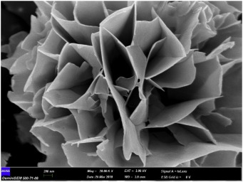

Figure 1.2.4 Three-Dimensional Nanomaterial

**1.3 Properties of Nanomaterials**

Nanomaterials vary significantly from their bulk counterparts owing to their spatial confinement of subatomic particles. Some of the properties of nanoparticles are:

**1.3.1 Solvent affinity:**

The solvent affinity property of nanoparticles refers to their ability to interact with solvents and to have different solubility characteristics compared to their bulk counterparts. Due to their high surface area to volume ratio, nanoparticles have a large number of surface atoms or molecules that can interact with the solvent molecules. This interaction can lead to changes in the thermodynamic properties of the system, such as the solubility of the nanoparticles.

**1.3.2 Diffusion across the surface:**

Diffusion across the surface property of nanomaterials refers to the movement of particles or molecules across the surface of nanoparticles. Due to their small size and high surface area to volume ratio, nanoparticles have many surface atoms or molecules that can interact with the environment, including gases, liquids, and other solids.

**1.3.3 Melting point depression:**

Melting point depression is a property of nanomaterials that refers to the reduction in the melting point of a substance when it is in the form of nanoparticles compared to its bulk form. This phenomenon is due to the high surface area to volume ratio of nanoparticles, which leads to a larger percentage of atoms or molecules located at the surface of the particle.

**1.4 Synthesis approach for nanoparticle preparation**:

Top-down and bottom-up are two different approaches to the synthesis of nanoparticles.

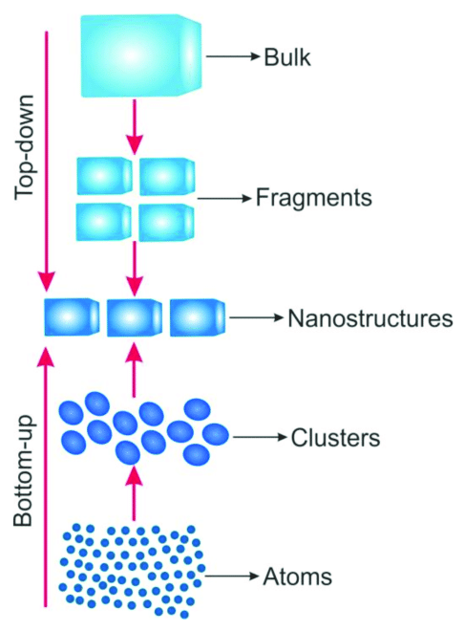

Figure 1.4 Synthesis approach for nanoparticle preparation:

**1.4.1 Top-down approach**

Top-down approach: In the top-down approach, nanoparticles are produced by breaking down a larger material into smaller pieces. This is usually achieved through physical methods such as milling, grinding, or laser ablation. The top-down approach is often used to produce nanoparticles from bulk materials, such as metals, ceramics, or polymers. This approach can produce large quantities of nanoparticles but may result in a wide size distribution and poor control over the particle shape and surface properties.

**1.4.2 Bottom-up approach**

Bottom-up approach: In the bottom-up approach, nanoparticles are built up from smaller units, such as atoms or molecules. This can be achieved through chemical methods, such as chemical reduction, sol-gel synthesis, or electrochemical synthesis. The bottom-up approach allows for precise control over the size, shape, and surface properties of nanoparticles. However, this approach can be more time-consuming and may produce smaller quantities of nanoparticles compared to the top-down approach.

**1.5 Introduction to transition metal oxide**:

Metal oxides, especially transition metal oxides comprise a very diverse and fascinating class of compounds with properties covering almost all aspects of material science and physics. The bonding characteristics may be classified as covalent for one system and highly ionic for the other. For the electrical conductivity, they cover the entire range from metals to semiconductors and insulators. For example, they can be insulators (CoO, NiO, BaTiO3), semiconductors (Fe0.9O), metals (CrO2, ReO3) and superconductors (YBa2Cu3O7). They can be ferromagnetic (CrO2), anti-ferromagnetic (CoO, NiO), ferrimagnetic (Fe3O4, Y3Fe5O12) and ferroelectric (BaTiO3). Many oxides have different oxidation stats, e.g. vanadium oxide (VO, VO2, V2O3 and V2O5). For the crystal structure, they can be simple binary monoxides (NiO, CoO) with NaCl structure or ternary oxides (BaTiO3, SrTiO3) with perovskite structure. They also can form complicated structures such as Co3O4 or Fe3O4 with the normal and/or inverse spinel structure. Due to the diverse physical and chemical properties, transition metal oxides find applications in many fields of technical interest, from nonlinear optics to sensors and catalysis.

**1.5.1 MoO3 Nanostructures**

The transition-metal oxide MoO3 is an important semiconductor and has various technological applications in catalysts, electrochromic and photochromic devices, gas sensors, and battery electrodes. Molybdenum oxide possesses layered crystal structure stacked on top of one another and is an n-type semiconductor having a band gap of 3 -3.2 eV, high work function (> 6 eV) and low temperature deposition. Mn dopants are also amphoteric, and they show interesting magnetic properties.

**1.5.2 Crystal and Surface Structure of MoO3**

Although MoO3 can exist in orthorhombic as a-MoO3, monoclinic b-MoO3, or hexagonal h- MoO3, we will mainly be discovering MoO3 orthorhombic structures. Mo⁶⁺ is bonded in a 6-coordinate geometry to six O²⁻ atoms forming a three-dimensional network. There is a spread of Mo–O bond distances ranging from 1.66–2.39 Å with the lattice constants; a = 0.396 nm, b = 1.385 nm and c = 0.369 nm. The unit cell contains four formula units of MoO3, with each formula unit consisting of one Mo atom and three O atoms.

The surface structure of MoO3 depends on the crystallographic orientation of the surface. The (010) surface is the most stable and is terminated by planes of oxygen atoms. The (001) surface, which is less stable, is terminated by planes of molybdenum atoms. The (100) surface is unstable and is rarely observed in experiments.

The surface of MoO3 can be modified by various techniques, such as chemical vapor deposition, electrochemical deposition, and annealing in different atmospheres. These modifications can lead to changes in the surface structure, morphology, and properties of the material, making it useful for a variety of applications, including catalysis, energy storage, and electronic devices.

**1.5.3 Applications of MoO3 Nanoparticles**

Molybdenum trioxide (MoO3) nanoparticles have several industrial applications, including:

**Catalysis**: MoO3 nanoparticles are widely used as catalysts in various chemical reactions due to their high surface area and unique electronic and structural properties. They are used in the production of formaldehyde, acrylonitrile, and sulfuric acid.

**Energy storage**: MoO3 nanoparticles are used as electrode materials in lithium-ion batteries due to their high specific capacity and excellent cyclic stability.

**Gas sensors**: MoO3 nanoparticles are used as gas sensors for the detection of harmful gases such as NO, CO, and H2S. They offer high sensitivity, selectivity, and stability.

**Electrochromic devices**: MoO3 nanoparticles are used in the production of electrochromic devices such as smart windows, which can switch between transparent and opaque states by applying an electric field. They offer high contrast, fast switching, and low power consumption.

**Photocatalysis**: MoO3 nanoparticles can be used as photocatalysts for the degradation of organic pollutants in water and air. They offer high activity, stability, and selectivity.

Overall, the unique properties of MoO3 nanoparticles make them promising materials for various industrial applications, and their use is expected to increase in the future.

**Chapter 2**

**LITERATURE REVIEW**

Yunfei Mo suggested the synthesis of orthorhombic molybdenum trioxide nanobelt using facile hydrothermal method and characterized with the aid of using X ray diffraction (XRD), scanning electron microscopy (SEM) and transmission electron microscopy (TEM). The intrinsic structural anisotropy of the material results in tuning its properties by interlayer structural modification. They prepared 1D nanostructure of MoO3 with controllable size and morphology. XRD pattern indexed to the orthorhombic Moo3 nanostructure. SEM images results showed MoO3 nanobelt morphology [1].

S wang reported the synthesis of MoO3-MnO2 by using one step Hydrothermal method. X-ray diffraction, transmission electron microscopy and X-ray Photoelectron spectroscopy analyses display the biphasic intergrown nanocrystalline debris of MoO3 and MnO2 with a slender length distribution starting from 6 nm to eight nm. Mo(6+) is embedded into MnO2 to assist its crystal lattice, while Mn(4+) is integrated into the MoO3 lattice to alter its crystal shape. The synergistic intergrowth of the biphases significantly improves the structural balance and its electric conductivity of the MoO3-MnO2 composite [2].

Zeng at al reported One-dimensional MoO3 nanobelts have been synthesized for the first tune from molybdic acid in a solvent of oxalic acid with the addition of nitric acid via a facile hydrothermal method. The morphology and structure of the as-prepared nanocomposite have been thoroughly characterized by the combination of different techniques. According to XRD analysis, the obtained MoO3 nanobelts are single-crystalline with an orthorhombic structure. XPS analysis proves that Mo is in its highest oxidation state of +6. In addition, the obtained nanobelts that have a width ranging from 100 nm to 300 nm, together with a length in micrometers are observed through TEM and FESEM. Furthermore, the possible growth mechanism is also investigated [3].

Sen et al proposed the nanocrystalline pure and silver (0.2, 0.4, 0.6, and 0.8 M%)-doped hexagonal molybdenum trioxide rods synthesized by using facile and cost-effective hydrothermal method and analyzed the effects of Ag contents of different microstructural and optical properties. X-ray diffraction (XRD) patterns confirmed the hexagonal crystal structure of the nanorods, supported by FTIR spectra. The Debye–Scherrer formula, Williamson–Hall (W–H), Halder–Wag-ner (H–W), and size–strain plot (SSP) techniques were applied to investigate different crystallographic characteristics such as crystallite size and lattice strain of h-MoO3 nanorods by evaluating the broadening of XRD peaks. The different relevant structural parameters of the resultant h-MoO3 nanorods connected to XRD analysis such as dislocation density, lattice param-eters, unit cell volume, and stacking fault have also been evaluated. The formation of nanorod shape and the presence of Ag contents were confirmed by field emission scanning electron microscope and energy-dispersive spectroscopy, respectively. The optical bandgap was estimated via both Kubelka–Munk (K–M) and Tauc’s rules. The estimated values of the bandgap were found to be in the range of 2.83–3.04 eV. The optical bandgap increased with the increased of Ag contents up to 0.4 M% and afterword decreased up to 0.8 M%. The similar variation trend of optical bandgap was observed for both methods [4].

Chithambararaj et al synthesized Molybdenum oxide with two different crystal structures using powerful and environmental friendly hydrothermal method. The phase confirmation and structural properties of the sample evaluated through X ray diffraction (XRD) method. The reaction temperature has great impact on the crystal structure, size and chemical composition of the samples Vibration characteristics of chemical bonds evaluated using Fourier transform infrared spectroscopy (Fi-IR) and peaks verified the formation of MoO3. Scanning electron microscopy (SEM) indicates that for increase in reaction temperature, the shape became considerably modified from one dimensional to 2 dimensional layered structures. Energy dispersive X-ray evaluation (EDX) well-known shows that the prepared samples are in non-stoichiometric composition and their composition varies with reaction temperature. Optical absorption properties measured using the diffuse reflectance spectroscopy (DRS) and the band gap energy, estimated from Kubelka-Munk function (K-M) which is obtained in the range of 3.01-3.24eV [5].

**Chapter 3**

**CHARACTERIZATION TECHNIQUES**

Characterization in nanotechnology means it is the classification of specific properties of nanomaterials to determine it, its characteristic and analytical method depending on its physical and chemical properties to be determined.

1) X-Ray diffraction technique (XRD)

2) Field Emission Scanning Electron Microscopy (FESEM)

3) UV -spectroscopy

**3.1 X-Ray Diffraction Technique (XRD)**

X-ray powder diffraction (XRD) is a rapid analytical technique primarily used for phase identification of a crystalline material and can provide information on unit cell dimensions. The analyzed material is finely ground, homogenized, and average bulk composition is determined.

**3.1.1 Principle**

Max von Laue, in 1912, discovered that crystalline substances act as three-dimensional diffraction gratings for X-ray wavelengths like the spacing of planes in a crystal lattice. X-ray diffraction is now a common technique for the study of crystal structures and atomic spacing

X-Ray diffraction is based on constructive interference of monochromatic X-rays and a crystalline sample. These X-rays are generated by a cathode ray tube, filtered to produce monochromatic radiation, collimated to concentrate, and directed toward the sample. The interaction of the incident rays with the sample produces constructive interference (and a diffracted ray) when conditions satisfy Bragg's Law expressed as:

**nλ = 2d sinθ**

where n is an integer, λ is the wavelength of incident wave, d is the spacing between the planes

in the atomic lattice and θ is the angle between the incident ray and the scattering planes. This law relates the wavelength of electromagnetic radiation to the diffraction angle and the lattice spacing in a crystalline sample. These diffracted X-rays are then detected, processed and counted. By scanning the sample through a range of 2θ angles, all possible diffraction directions of the lattice should be attained due to the random orientation of the powdered material. Conversion of the diffraction peaks to d-spacings allows identification of the mineral because each mineral has a set of unique d-spacings. Typically, this is achieved by comparison of d-spacings with standard reference patterns.

All diffraction methods are based on generation of X-rays in an X-ray tube. These X-rays are directed at the sample, and the diffracted rays are collected.

When an X-ray is shined on a crystal, it diffracts in a pattern characteristic of the structure. In

powder X-ray diffraction, the diffraction pattern is obtained from a powder of the material,

rather than an individual crystal. Powder diffraction is often easier and more convenient

than single crystal diffraction since it does not require individual crystals be made.

Powder X-Ray diffraction (XRD) also obtains a diffraction pattern for the bulk material of a crystalline solid, rather than of a single crystal, which doesn't necessarily represent the overall

material. A diffraction pattern plots intensity against the angle of the detector.

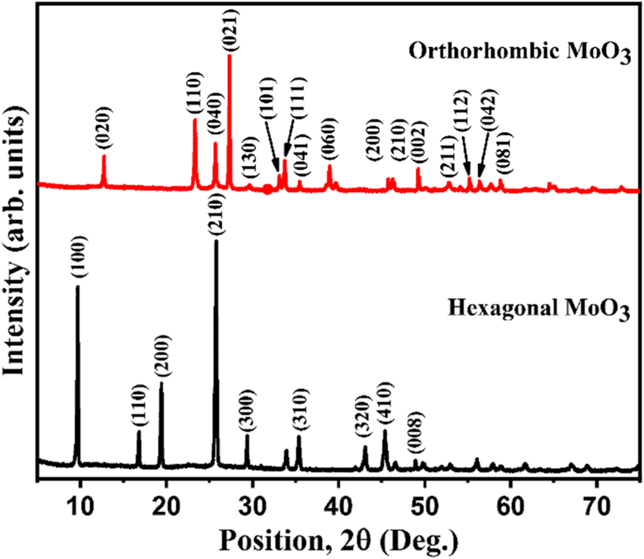

Figure3.1.1 XRD patterns of h-MoO3 nanorods and α-MoO3 nanoplates

**3.1.2 Braggs law**

X-rays are partially scattered by atoms when they strike the surface of a crystal. The part of

the X-ray that is not scattered passes through to the next layer of atoms, where again part of

the X-ray is scattered, and part passes through to the next layer. This causes an overall

diffraction pattern, like how a grating diffracts a beam of light. For an X-ray to

diffract the sample must be crystalline and the spacing between atom layers must be close to

the radiation wavelength. If beams diffracted by two different layers are in

phase, constructive interference occurs, and the diffraction pattern shows a peak, however if

they are out of phase; destructive interference occurs appear and there is no peak. Since a highly regular structure is needed for diffraction to occur, only crystalline solids will diffract; amorphous materials will not show up in a diffraction.

**3.1.3 Instrumentation**

X-ray diffraction is a non-destructive solid technique for delineating crystalline materials. It gives information on phases, structures, favored crystal orientations (texture), and different structural parameters, such as strain, crystallinity, medium grainsize, and crystal cracks. XRD peaks are designed by the constructive intervention of a monochromatic beam of X-rays interspersed at distinct angles from each collection of lattice planes in a specimen. The peak

intensities are defined by the atomic positions inside the lattice planes. Consequently, the XRD design is the fingerprint of periodic atomic methods in a dispensed material. A standard database of online research for X-ray powder diffraction patterns allows quick phase identification for a wide variety of crystalline samples. Diffraction results from radiation scattered by a regular array of scattering centers whose spacing is the same radiation. Diffraction gratings need to have

spacings equivalent to the wavelength of diffracted radiation.

**3.2 Field Emission Scanning Electron Microscopy (FESEM)**

Field emission scanning electron microscopy (FE-SEM) is an advanced technology used to

capture the microstructure image of the materials. FE-SEM is typically performed in a

high vacuum because gas molecules tend to disturb the electron beam and the emitted

secondary and backscattered electrons used for imaging. To characterize the specimens

in this study, Zeiss Crossbeam 340 was used to capture the microstructure image. The

specimens (except powder) were cut into smaller sizes of about 5x5x5 mm and coated using aurum prior to the morphological observation. In addition to FE-SEM, energy-dispersive X-ray was conducted on the same specimens for further analysis. EDX is an X-ray technique used to identify the elemental composition of materials. These systems are attachments to electron microscopy instruments where the imaging capability of the microscope identifies the specimens of interest.

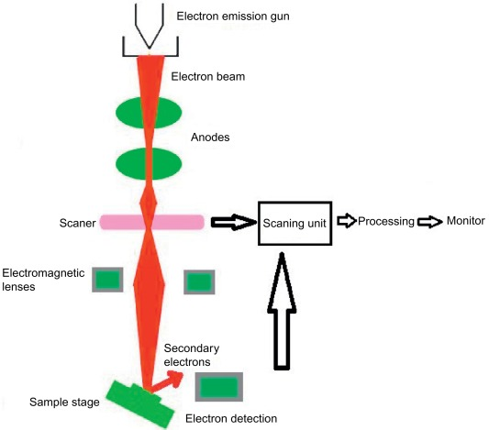

Figure 3.2.1 FESEM Schematic Diagram

**3.2.1 Advantages of FESEM**

FESEM can examine minor area contamination spots at electron accelerating

voltages well-matched with EDS. In field emission TEM, penetration can be reduced with

the aid of low-kinetic-energy electrons that probe nearer to the immediate material surface.

Moreover, high-quality and low-voltage images with slight electrical charging of samples can be obtained.

**3.2.2 Applications of FESEM include:**

• Semiconductor device cross section analyses for gate widths, gate oxides, film

thicknesses, and construction details.

• Advanced coating thickness and structure uniformity determination.

• Small contamination feature geometry and elemental composition measurement.

**3.3 UV-visible Spectroscopy**

(UV-Vis or UV/Vis) refers to absorption spectroscopy or reflectance spectroscopy in part of the ultraviolet and the full, adjacent visible regions of the electromagnetic spectrum. Being relatively inexpensive and easily implemented, this methodology is widely used in diverse applied and fundamental applications. The only requirement is that the sample absorbs in the UV-Vis region, be a chromophore. Absorption spectroscopy is complementary to fluorescence spectroscopy.

Parameters of interest, besides the wavelength of measurement, are absorbance or transmittance or reflectance, also includes its change with time.

What is UV spectroscopy?

UV spectroscopy is an analytical technique that measures the number of discrete wavelengths of UV or visible light that are absorbed by or transmitted through a sample in comparison to a reference or blank sample. This property is influenced by the sample composition, potentially providing information on what is in the sample and at what concentration. Since this spectroscopy technique relies on the use of light, let's first consider the properties of light.

Light has a certain amount of energy which is inversely proportional to its wavelength.

Thus, shorter wavelengths of light carry more energy and longer wavelengths carry less energy. A specific amount of energy is needed to promote electrons in a substance to a higher energy state which we can detect as absorption. Electrons in different bonding environments in a substance require a different specific amount of energy to promote the electrons to a higher energy state. This is why the absorption of light occurs for different wavelengths in different substances. Humans can see a spectrum of visible light, from approximately 380 nm, which we see as violet, to 780 nm, which we see as red. UV light has wavelengths shorter than that of visible light to approximately 100 nm.

**3.3.1 Principle of UV-Visible Spectroscopy**

The Principle of UV-Visible Spectroscopy is based on the absorption of ultraviolet light or visible light by chemical compounds, which results in the production of distinct spectra. Spectroscopy is based on the interaction between light and matter. When the matter absorbs the light, it undergoes excitation and de-excitation, resulting in the production of a spectrum.

When matter absorbs ultraviolet radiation, the electrons present in it undergo excitation. This

causes them to jump from a ground state (an energy state with a relatively small amount of energy associated with it) to an excited state (an energy state with a relatively large amount of energy associated with it). It is important to note that the difference in the energies of the ground state and the excited state of the electron is always equal to the amount of ultraviolet radiation or visible radiation absorbed by it.

**3.3.3 Instrumentation**

1. Light source

2. Diffraction grating

3. Wavelength selector

4. Sample container or cuvette

5. Detector

**1. Light Source**

Light sources that lie in the ultraviolet and visible region are used as UV-visible spectrometer sources.

* Hydrogen & deuterium lamps range 160-380nm
* Xenon arc lamps range 250-600nm
* Tungsten halogen lamps range 240-2500nm

**2. Diffraction Grating**

A diffraction grating is an optical component that consists of many equally spaced parallel lines or grooves etched onto a flat surface. When a beam of light passes through or reflects off the grating, the light is diffracted into multiple beams that travel in different directions, with each beam corresponding to a different wavelength.

The diffracted beams are characterized by their diffraction angles, which depend on the wavelength of the incident light and the spacing between the grating lines. The spacing between the lines is typically on the order of the wavelength of light, which allows for efficient diffraction.

**3. Wavelength Selector**

UV spectroscopy requires a single wavelength for proper functioning whereas the ideal output of a single wavelength is not possible. This is so because no real wavelength selector is ideal. Although a single wavelength is not possible, a band of radiation could be used. So, an instrument with a narrow bandwidth would be better.

Types of the wavelength selectors

1. Filters

2. Monochromators

**4. Sample Container**

The purpose of the sample container is to ensure that the sample is held in a consistent and reproducible manner during the UV spectroscopy analysis. The container also prevents contamination of the sample and allows for easy cleaning between samples. The container is typically made of a material that is transparent to UV light, such as quartz or fused silica, and has a rectangular or cylindrical shape. Only quartz is transparent in both UV & visible regions (200-700nm range). Glass & plastic are suitable for the visible region only. Glass is not suitable for the UV region because it absorbs UV radiation i.e. it is not transparent in the UV region.

**5. Detectors**

Detectors are devices that indicate the existence of some physical phenomenon.

Some examples of simple detectors are Transducers, Photodetectors, Photographic film, Human Eye.

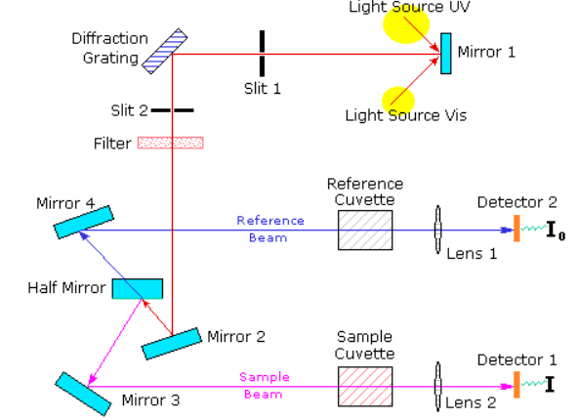

Figure 3.3.1 UV Spectroscopy schematic Diagram

**Chapter 4**

**SYNTHESIS OF NANOPARTICLES**

**4.1 Hydrothermal Method**

The hydrothermal method is a popular technique for synthesizing nanoparticles, particularly metal oxide nanoparticles, under high-temperature and high-pressure conditions in an aqueous medium. The method involves the reaction of precursor materials in an autoclave (a sealed vessel) containing water or another solvent, which is heated above the boiling point at the desired pressure. The precursor materials undergo hydrolysis, condensation, and nucleation reactions to form nanoparticles, which are then stabilized and separated from the solution. This effect of high temperature and pressure provides a one step process to produce highly crystalline materials without the need for post annealing treatment.

Hydrothermal Autoclave Reactor is a specific style of strong vessel that we intend to face up to high temperatures and better pressure levels from within. The autoclave reactor consists of thick and steel-walled cylindrical vessels having hermetic sealing. Likewise, this helps it to bear high levels of heat and pressure regularly and safely, for a long time. Also, the fabric of the autoclave also must be resistant to solvents. While the most vital part of the hydrothermal autoclave reactor is probably the ‘closure’. Apart from this, the seals are a successive necessary part of the autoclave. Many hydrothermal processes need to use solutions having a corrosive impact on the interior material of the autoclave. Also, we apply special protective coatings to prevent corrosion. Because we usually design to suit the interior of the autoclave seamlessly and can either cover the entire interior of the autoclave or part of it.

The hydrothermal method offers several advantages over other methods of nanoparticle synthesis. First, the method can produce nanoparticles with a narrow size distribution, high purity, and crystallinity, which are important for many applications. Second, the method allows for control over the shape, size, and composition of the nanoparticles by adjusting the reaction conditions, such as temperature, pressure, pH, and precursor concentration. Third, the method is relatively simple and cost-effective compared to other methods, such as chemical vapor deposition or physical vapor deposition. Minimized consumption of energy, particularly for complex and doped oxides of high homogeneity than solid state processing, high homogeneity than solid state processing are some of the other advantages.

The hydrothermal method has been used to synthesize a wide range of metal oxide nanoparticles, such as TiO2, ZnO, Fe2O3, and SnO2 which have applications in catalysis, photocatalysis, energy storage, and biomedicine. The method has also been extended to the synthesis of other types of nanoparticles, such as carbon-based nanoparticles and metal nanoparticles, by modifying the precursor materials and reaction conditions. Overall, the hydrothermal method is a versatile and effective technique for synthesizing nanoparticles with controlled properties, and it is expected to play an increasingly important role in the development of new nanomaterials for various applications.

**Advantages**

* + - Precise control of size in nanoparticles.
    - Low melting point
    - High vapor pressure
    - Produce nanocrystal with crystallinity.

**Disadvantages**

* + - Crystal growth information cannot observe directly
    - Expensive autoclave
    - Difficult to control
    - Accidental explosion of the high-pressure vessel cannot be ruled.

**4.2 Synthesis of MoO3 by Hydrothermal Method**

**Materials**

Sodium molybdate, HCl, Deionized water

**Synthesis of MoO3 nanostructure**

Hydrothermal method is opted for the synthesis of nanoparticles. 1M sodium molybdate solution was prepared initially to which appropriate amount of HCl was added to maintain the pH to 1-2. The mixture was stirred vigorously for 30 minutes. A white color precipitate is formed and was transferred into a Teflon lined autoclave and placed in the oven at 150oC for 24h. After the desired reaction time, it is allowed to cool naturally to room temperature. The resultant products were washed, filtered and dried at 95oC for 5h. Then the powder was calcinated at 500oC for 5h.

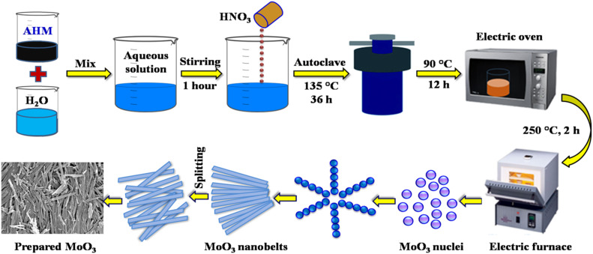

Figure 4.2.1 Synthesis of MoO3 by Hydrothermal Method

**Chapter 5**

**RESULTS AND DISCUSSION**

**5.1. Structural analysis**

XRD spectra of MoO3 nanostructures were shown in the figure. The peaks have been found to be quite sharp and intense, which implies high crystallinity of the sample. Peaks were observed at 2θ values which corresponds to the MoO3 crystal planes. The diffraction peaks are in good agreement with the standard JCPDS data (file no: 21-0569). The main diffraction peaks corresponding to (210), (300) and (200) planes showed P63 space group and a pure crystalline hexagonal MoO3 nanostructure. The most intense peak at 25.2o belongs to the plane (210) of hexagonal MoO3 [6-7].

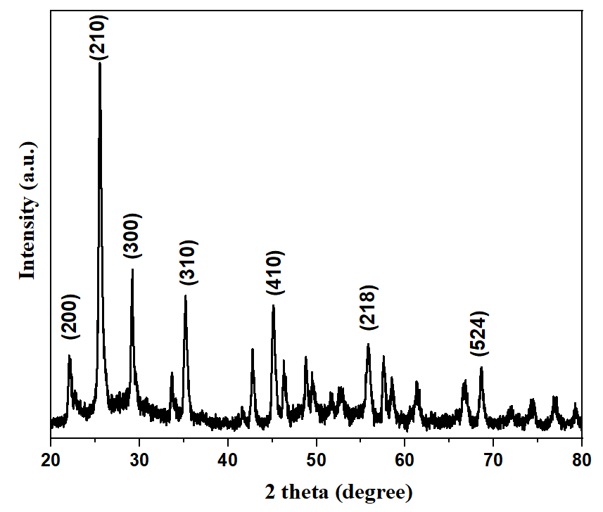

Figure 5.1. XRD pattern of MoO3 nanostructure hydrothermally

synthesized at 150oC for 24hr

The average crystalline size of the samples was estimated using Debye Scherrer equation,

D $= \frac{0.9 λ}{βcosθ}$

Where D is the crystalline size, $λ$ is the radiation wavelength (0.15417 nm), $β$ I is the full width at half maximum (FWHM) and $θ$ is the Bragg diffraction angle. The average crystalline size of the sample is found to be 18.81 nm.

**5.2. Optical studies**

Optical absorption spectra of MoO3 samples in the UV-Vis range shows low absorbance in the spectral region above 400 nm. Optical bandgap energy calculated by Kubelka Munk function which is based on the following equation:

$$F\left(R\right)= \frac{{(1-R)}^{2}}{2R}$$

R refers to the reflectance and F(R) is the absorption constant of the material. A is the proportionality constant, h is Planck's Constant, $ϑ$ is the frequency of incident photon in Hz, $E_{g }$ is the bandgap energy in eV and n is the power factor which has values ½ for direct allowed transitions, 3/2 for direct forbidden and 2 or 3 for indirect allowed or indirect forbidden transitions [8]. To determine the bandgap of the material, [F(R)*hv]2 is plotted against the photon energy for direct transition which is plotted in the figure.

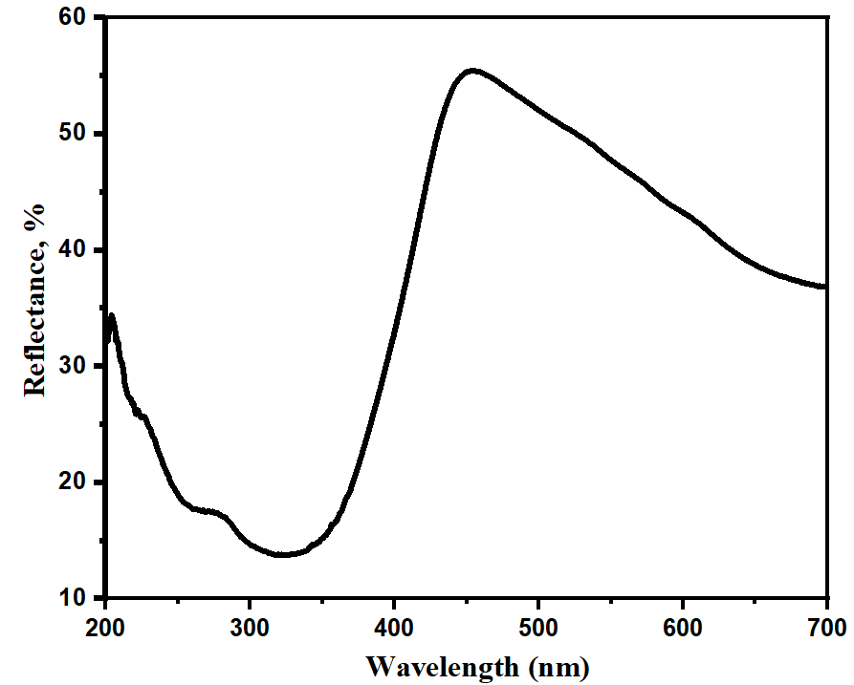 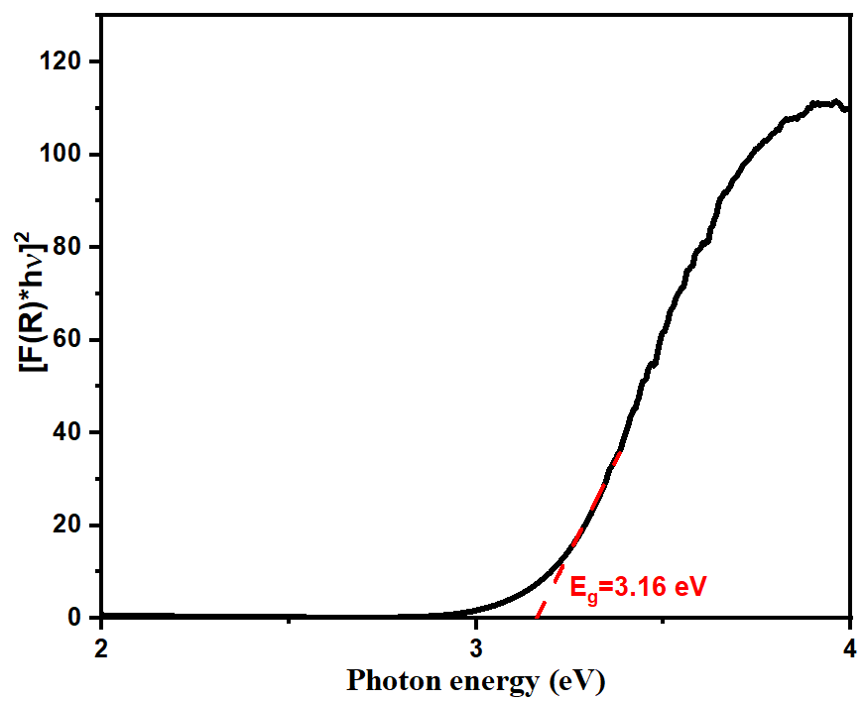Figure 5.2.1 Graph showing Reflectance

against wavelength Figure 5.2.2 Reflectance spectra (left)

and Tauc plot (right) of MoO3

nanostructures hydrothermally

synthesized at 150oC for 24 hrs.

**5.3. FESEM Analysis**

The surface morphology of nanoparticles can be determined using Field Emission Scanning Electron Microscopy (FESEM). FESSEM micrographs of the prepared sample is shown in figure 5.3.1. The result shows that MoO3 nanostructure showing a nanorod like morphology with average grain size obtained from the grain size distribution as 27 nm.

C:\Users\ACER\Desktop\Extra\ZNO\ZNO SEM\2.5NiZnO.005.tif

Figure 5.3.1 FESEM images showing the MoO3 nanorods hydrothermally synthesized at 150oC for 24hr

**Chapter 6**

**CONCLUSION**

MoO3 nanostructure was successfully synthesized by using hydrothermal method. This sample was characterized by three characterization techniques such as

1. X-Ray Diffraction (XRD)

2. Field Emission Scanning Electron Microscopy (FESEM)

3. UV-Vis absorption spectroscopy

* From XRD analysis, MoO3 nanostructure has shown highly crystalline and crystallized hexagonal structure. The average crystallite size of MoO3 nanoparticle is found to be 18.81 nm.
* FESEM analysis shows clear nanorod morphology with an average grain size of around 27 nm.
* UV visible spectroscopic study shows MoO3 is a direct bandgap material. The calculated bandgap energy of MoO3 nanostructure is 3.16 eV.

**REFERENCES**

1. Mo, Y., Tan, Z., Sun, L., Lu, Y., & Liu, X. (2020). Ethanol-sensing properties of α-MoO3 nanobelts synthesized by hydrothermal method. Journal of Alloys and Compounds, 812, 152166. doi: 10.1016/j.jallcom.2019.152166.
2. Wang, S., Li, Q., Pu, W., Wu, Y., & Yang, M. (2016). MoO3 –MnO2 intergrown nanoparticle composite prepared by one-step hydrothermal synthesis as anode for lithium ion batteries. Journal of Alloys and Compounds, 663, 148–155. doi: 10.1016/j.jallcom.2015.12.040.
3. Zeng, X., Zhang, X., Yang, M., & Qi, Y. (2013). A facile hydrothermal method for the fabrication of one-dimensional MoO3 nanobelts. Materials Letters, 112, 87–89. doi: 10.1016/j.matlet.2013.08.130.
4. Sen, S. K., Paul, T. C., Dutta, S., Hossain, M. N., & Mia, M. N. H. (2019). XRD peak profile and optical properties analysis of Ag-doped h-MoO3 nanorods synthesized via hydrothermal method. Journal of Materials Science: Materials in Electronics, 31(2), 1768–1786. doi:10.1007/s10854-019-02694-y.
5. Chithambararaj, A., & Bose, A. C. (2011). Hydrothermal synthesis of hexagonal and orthorhombic MoO3 nanoparticles. Journal of Alloys and Compounds, 509(31), 8105–8110. doi: 10.1016/j.jallcom.2011.05.067.
6. Sen, S.K., Paul, T.C., Dutta, S. et al. (2020). XRD peak profile and optical properties analysis of Ag-doped h-MoO3 nanorods synthesized via hydrothermal method. J Mater Sci: Mater Electron 31, 1768–1786. <https://doi.org/10.1007/s10854-019-02694-y>
7. Mo, Y., Tan, Z., Sun, L., Lu, Y., & Liu, X. (2020). Ethanol-sensing properties of α-MoO3 nanobelts synthesized by hydrothermal method. Journal of Alloys and Compounds, 812, 152166.doi: 10.1016/j.jallcom.2019.152166.
8. Zeng, X., Zhang, X., Yang, M., & Qi, Y. (2013). A facile hydrothermal method for the fabrication of one-dimensional MoO3 nanobelts. Materials Letters, 112, 87–89. doi: 10.1016/j.matlet.2013.08.130